1. **Analyse a simple mechanical system**

* Consider the mass-spring-damper system shown below:

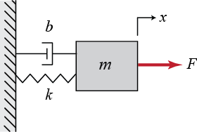

* Here we have a mass M connected to a fixed object by a spring with coefficient k and damper with coefficient b. The displacement from equilibrium position is given by distance x(t) and it can be moved by applying a force F(t) to the mass.
* Write down the differential equations of motion of the system.
* From your differential equation derive its Laplace transformation.
* Rearrange the equation for derived the transfer function of output position given input force F(s):

P(s) = X(s)/F(s)

* Use the following parameter values in the transfer function:

M = 1 kg

b = 4 N s/m

k = 5 N/m

F = 1 N

1. **Using initial and final value theorem**

* Use the Laplace initial and final value theorems to calculate:
* The initial response to a step input
* The final response to a step input
* HINT: Remember the factor s arising from the theorem and the factor 1/s arising from the step function!
* Show the algebraic steps in your calculation of both of these quantities.

1. **Bode plot of a transfer function**

* Use the Matlab tf function to generate a Matlab transfer function for the open loop system and place this in a variable P.
* If you display the contexts of transfer function variable P you should get the following output:

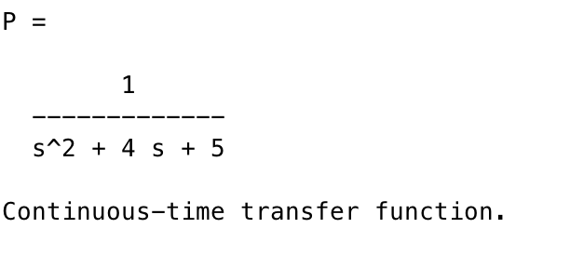

* Use Matlab to generate a Bode plot of the transfer function of the mechanical system.
* You should get a plot that looks like this:

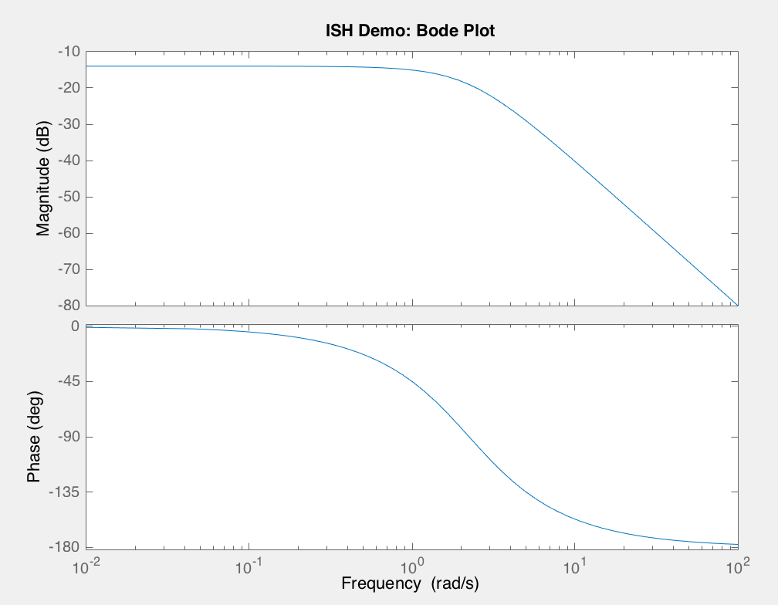

* Estimate the bandwidth of the transfer system from the Bode plot
* Use the Matlab step function to plot the step response of the system.
* Look at the Matlab help for step and also pass it a time vector that gives time values between 0 and 3 seconds in steps of 0.01 seconds.
* The output should look something like the plot below:

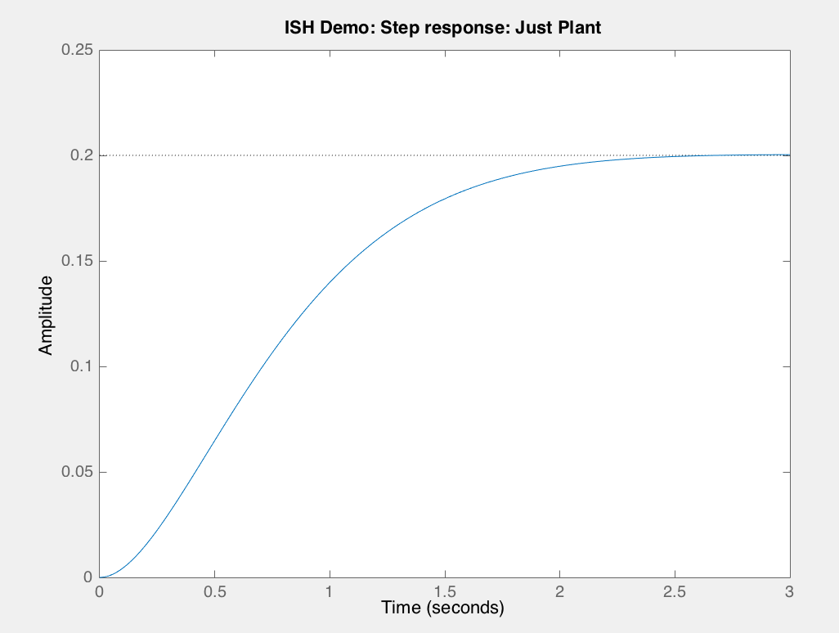

* Comment on the initial and steady state value of system.
* Do these values match those from the Laplace initial and final value theorems?

By looking at your plot

* What is the rise time of the response?
* What is the settle time of the response?

1. **PID controller**

Ensuring that a response quickly reaches unity without overshoot will be the goal of the PID control section in this laboratory task.

* You will now attempt to control the mass-spring-damper system using a PID controller.
* The action of a well-designed control system is to ensure we reach a target value quickly, without overshoot and with low steady state error.
* One method to achieve control uses a PID.
* This involves placing a PID controller C(s) in series with the plant P(s) and making use of negative feedback. This is illustrated below:

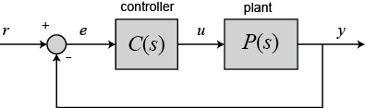

* The PID controller consists of three parallel elements:
* A proportional term that directly relates to the current error value
* The proportional gain is given as Kp
* Proportional gain can improve rise time
* If Kp too high the system can become unstable
* An integral term that is proportional to both the magnitude of the error and its duration
* The integrator gain is given as Ki
* Integral term eliminates residual steady-state error
* A derivative term that is proportional to the slope of the error over time
* The differentiator gain is given as Kd
* Derivative term improves settling time and stability of the system
* The relationship between input error e(t) and output control signal u(t) can be captured by the differential equation:



* Use Laplace transforms to write down the transfer function u(s)/(e(s) for this PID controller
* Write down the mathematical expression for the open loop response of the serial combination of the PID controller and plant

1. **Using feedback control with only proportional gain**

* You will now investigate the effect of just using a large proportional gain in controlling the mass-spring-damper system.
* Open loop performance of our mass-spring-damper plant is poor since the output from the system rises slowly and doesn’t reach unity.
* Set the proportional gain Kip to some relatively high value – e.g. try a value 300
* Set both **integral and differential** gains to **zero**
* Use Matlab code to express the transfer function of the open-loop gain of the system and show all the stages in you calculations in your Matlab code
* Now compute the closed-loop transfer function using the relationship for a feedback system
* HINT: remember for following system:

 



where C(s) is the transfer function of the PID controller and P(s) is the transfer function of the mass spring damper that you derived in section 1 and analysed in section 3.

* Using only a proportional gain of 300 you should end up with a closed-loop Matlab transfer function that looks like this:

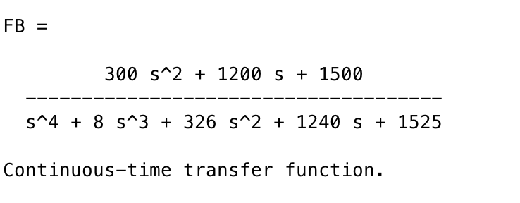

* Plot the step response of this transfer function using the same time points as used before for the open loop system.
* You should end up with a plot that looks something like this:

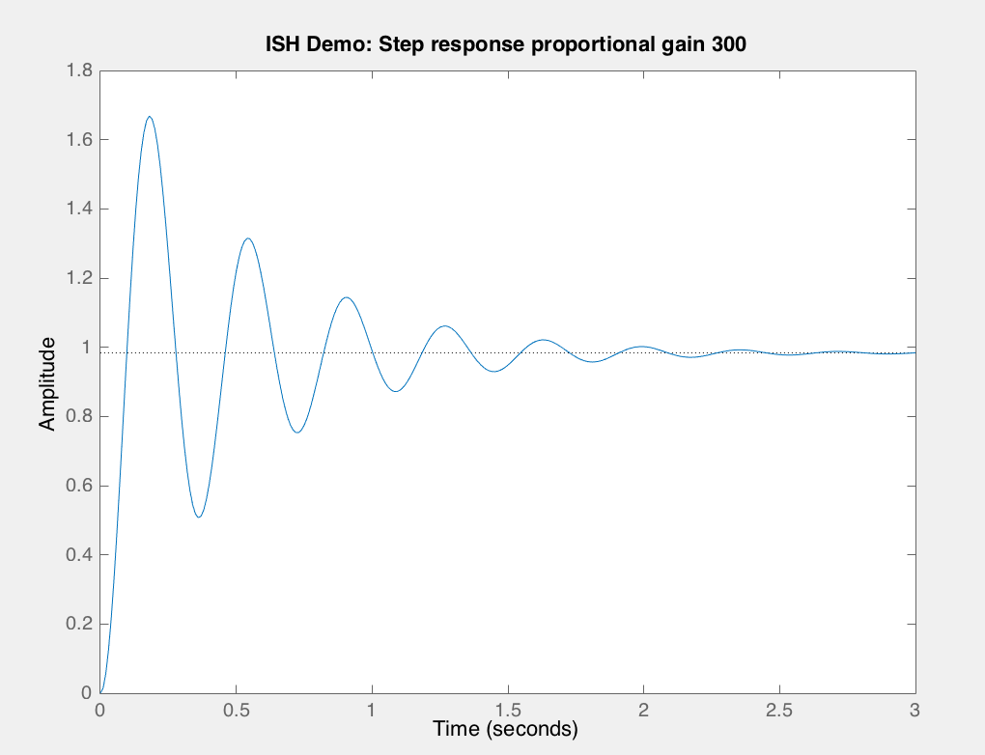

* What can you say about the response of the feedback system using a proportional gain of about 300?
* Consider the time behaviour mesaures of the system: risetime, overshoot, peak time, settle time and steady state error in your analysis. Use Matlab to check the value you see on the plot.
* HINT: The Matlab step function has options to display these values

1. **Using feedback control with proportional and differential gain**

* Now investigate the effect of using differential gain as well as proportional gain in controlling the mass-spring-damper system.
* The differential term should improve overshoot performance.
* Use proportional gain Kp of 300
* Also include a differential gain Kg of 20
* Once again compute the closed-loop transfer function using the relationship for a feedback system
* Plot the step response of this transfer function as before.
* You should end up with a plot that looks something like this:

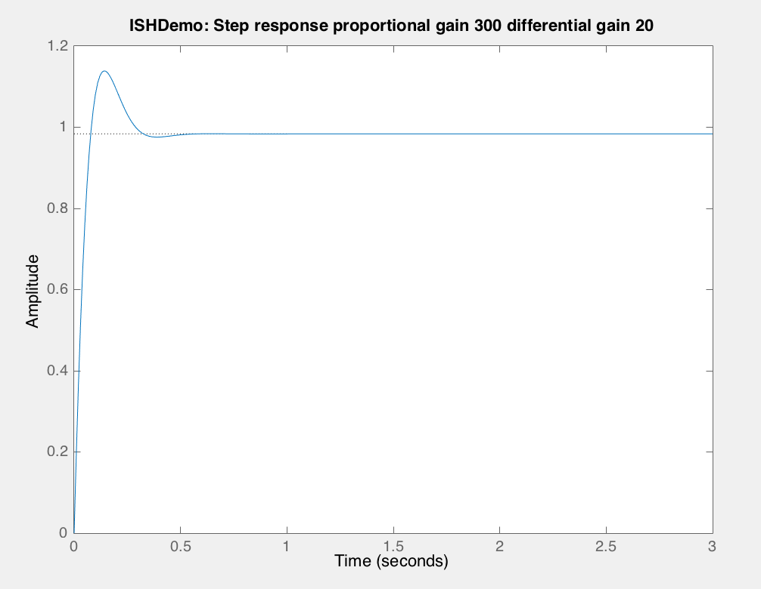

* What can you say about the response of the feedback system now?
* Again report the time behaviour mesaures of the system.

1. **Using feedback control with full PID**

* Investigate the effect of using full PID in controlling the mass-spring-damper system. Use:
  + Proportional gain Kp 350
  + Differential gain Kg of 50
  + Integral gain Ki of 300
* You should end up with a closed-loop Matlab transfer function that looks like this:

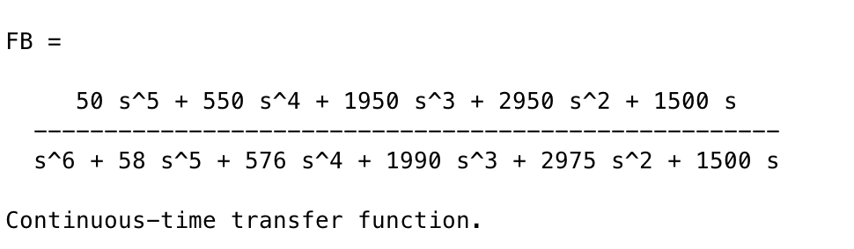

* Plot the step response of this transfer function as before.
* You should end up with a plot that looks something like this:

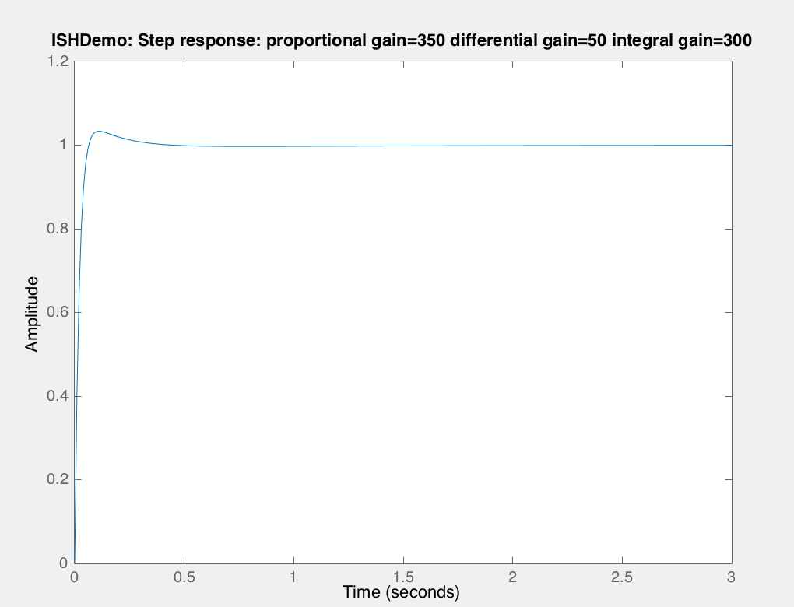

* Again report the time behaviour mesaures of the system.
* What can you say about the response of this feedback system?
* How does response compare with the open-loop response at the start of this practical session?
* What does this tell you about using PID control and feedback?